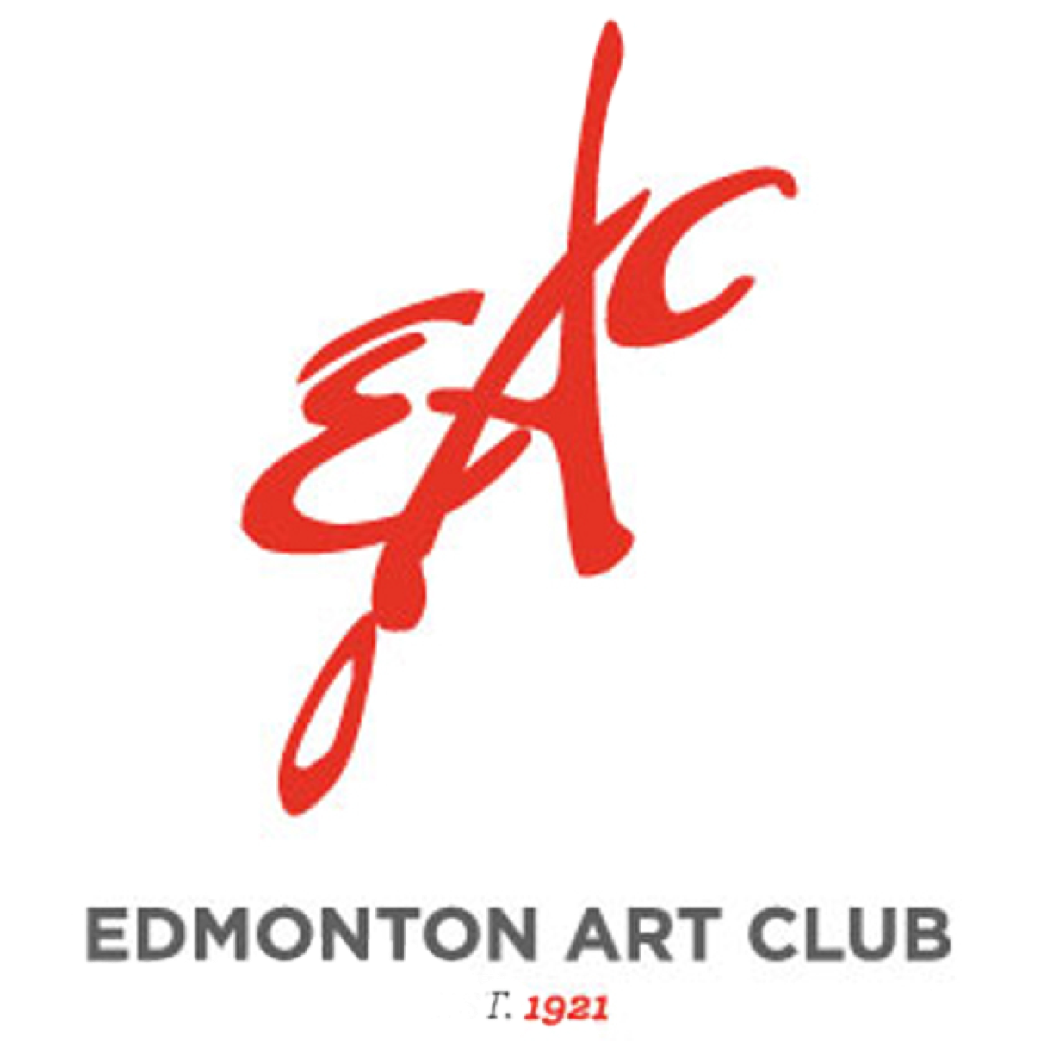
EAC September 10, 2020 NOTES:

Welcome!

We’ve put together an update for you - check it out, and if you have any questions or concerns, let somebody on the executive know!

- SAVE THE DATE!
Our first regular meeting since the Covid outbreak is scheduled for:
THURSDAY, OCTOBER 8, 2020
Rm. 440 Orange Hub (4th floor)
7:00 p.m.
Critic: TBA
This is a larger room, so we’ve got space for social distancing. Masks will not be required; sanitizer will be provided.

- ZOOM Meeting(s):
    - If you don’t feel comfortable coming to the meeting in person, would you be interested in joining us via ZOOM? If we get enough interest we could also consider this for our AGM. Technical support is available and it really is very easy!

- 2021 membership fees will be $37.50, reduced by 1/2 because of the 5 months when there were no meetings so we didn’t have to rent space. You can do an e-transfer to eacbetty@telus.net

- Show at the ATB Arts and Culture branch downtown November 2020 - January 2021. Please direct all enquiries to Connie Clarke. connieclarkeart@gmail.com

- 100 YEARS - 2021 celebration!
We have 5 projects planned:
      - August 27, 2021 and run for about 3 months (closing day TBC) a retrospective show of the EAC in one of their large main floor galleries. There is no cost to us. Seraya and Betty are meeting with them for planning.
*if you have any pieces from long ago members of the EAC please let Betty or Seraya know. We’ll pass the info on and see if they are interested in borrowing them
      - At the same time, at the AGA in the Community Gallery, we will have a show of work from current members of the EAC. Details are coming soon re. the size of piece you can submit, hanging details, etc. There will be some cost to us, hopefully covered by a grant.
      - A mosaic will be completed by members, to be hung at our EAC show at the AGA and then donated to them. We are planning this with the AGA specifications. Jani is the project coordinator for the mosaic - details of participation will come from her.
      - A book will be completed by Seraya with a page for each of our artists, and including your work hung at the EAC show in the AGA, your mosaic pieces and your photo and bio.

      - Betty is applying for a grant to cover all costs associated with our 2021 celebrations.

- Open Studio:
        - Are you interested in joining Open Studio in the Orange Hub? ($10 per session.)
We’d like to begin in October, again from 10:00 a.m. to 2:00 p.m. on the 2nd and 4th Tuesdays of each month.

Please let Betty know if you are interested.

        - If we don’t get enough participants, are you interested in joining Open Studio in Betty’s home? ($5.00 per session)
With the Covid lock down, Betty and Michael Dean did some basement renos, converting what was once Michael’s model railroad room to an art space, with 6, 6’ tables. Once it was safe to do so, Betty invited members who had previously been attending open studio at the Orange Hub to start an open studio in her basement - and then outside when the weather permitted.

At this point we only have room for 6 participants with only 1 person per table. However, if you have already included somebody in your ‘bubble’ you could share a table.

Please let Betty know if you are interested. We’ll operated every other Tuesday, 10:00 - 2:00.

- UPCOMING WORKSHOPS - open to EAC members and friends -

    - Mixed Media Madness November 28 & 29, 2020 10 - 4 p.m. $160.00
presented by Seraya and Jani in the Orange Hub
This workshop format will focus on mixed media application and techniques. Acrylic paint, gels, pastes and resin incorporating a variety of elements and much much more! Learn techniques that you can add to your art work.
    - Alcohol Inks with Betty $75 Saturday, October 24, 2020 10:00 a.m. - 2:30 p.m.
              - This will take place in Betty’s home
              - Limit of 6 participants unless you want to partner with somebody at the same table.
              - Repeat session on October 31, 2020 if enough people are interested.
              - Focus will on playing with the medium on different surfaces; all materials provided.

